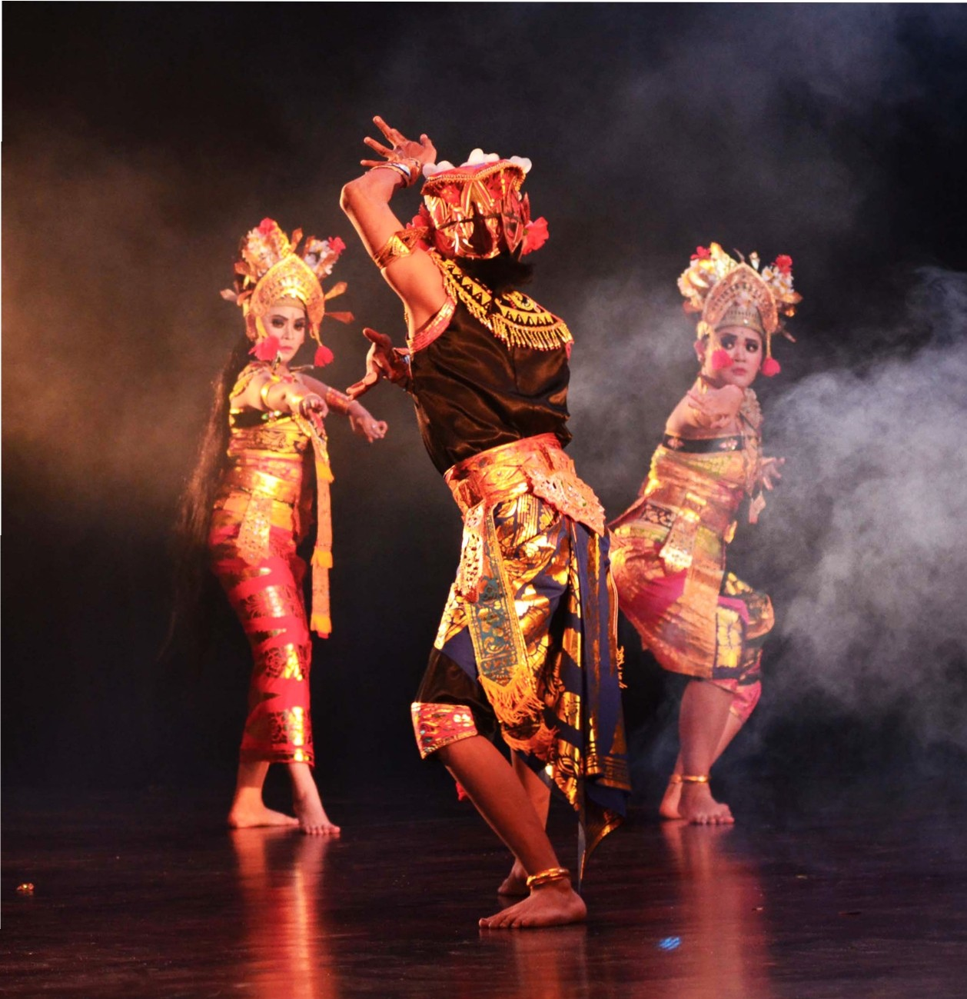KINANTHI BUDAYA

PRO FI L E

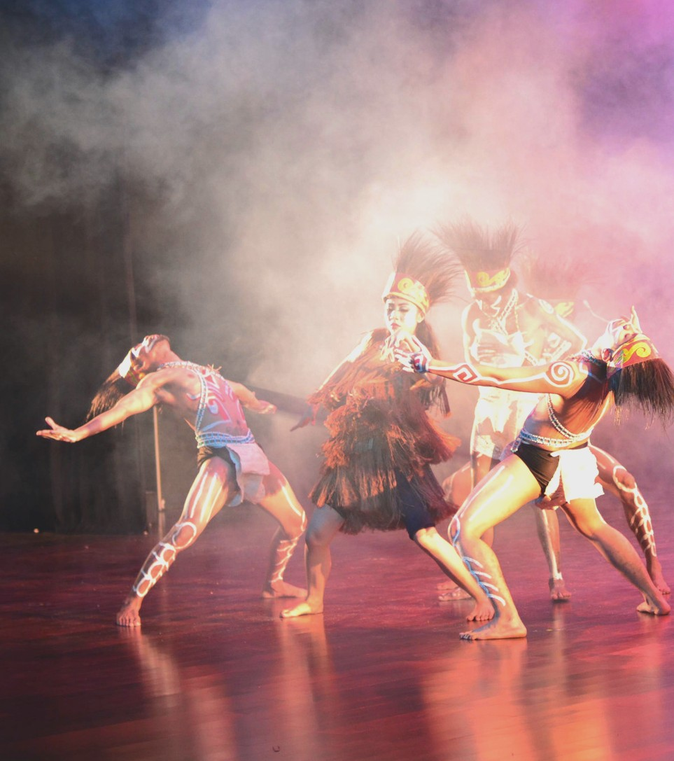O U R -
P R O F I L E

Kinanthi Budaya is an art and culture organization and community.
Seeing the fact that traditional art in the country is losing its number of creations.
Kinanthi Budaya was established in 2012 in order to conserve traditional art of Indonesia. Folklore countries that had been visited by Kinanthi Budaya are Czech Republic, Hungary, Brussels, France, Netherlands, and Berlin.

Traditional dance that had been performed are Saman (Aceh), Mambo Simbo (Papua), Lenggang Nyai (Jakarta), Baliuk Angkup (Kalimantan), Kecak (Bali), Jaipong (West Java) and several more traditional dance in Indonesia.

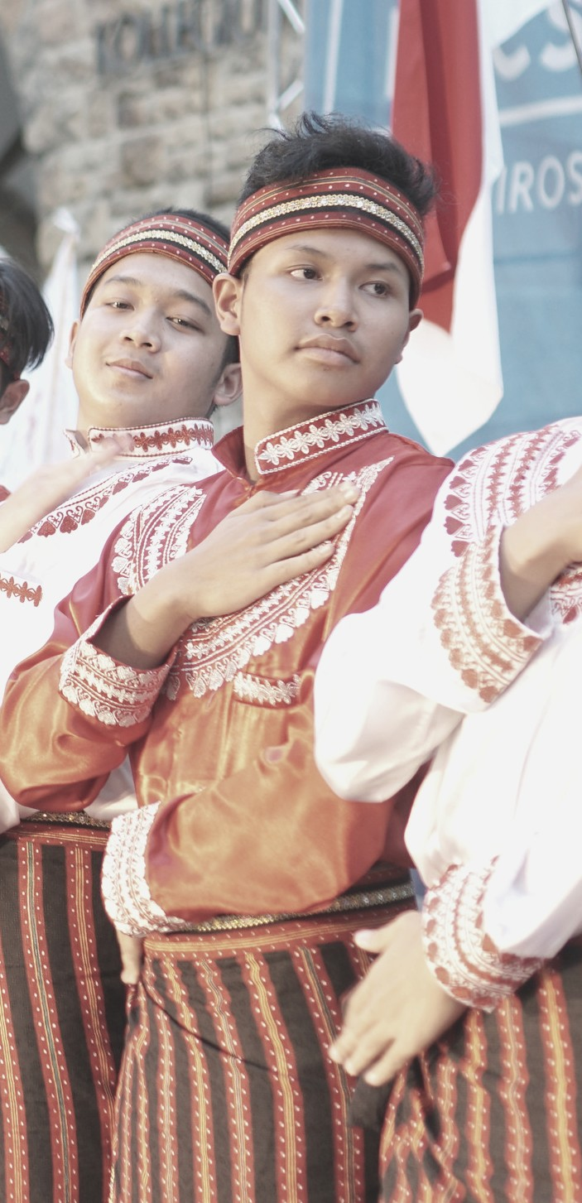WE CREATE,
WE DANCE, WE LOVE IT, WE BECOME.

K I N A N T H I B U D A Y A

S A M A N
D A N C E -

Saman (or the dance of a thousand hands) is one of the most popular dances in Indonesia. Its origin is from the Gayo ethnic group
from Gayo Lues, Aceh province, Sumatra, and is normally performed to celebrate important occasions.[1] The dance is characterized by its fast-paced rhythm and common harmony between dancers. These two elements are key figures of Saman, and are among the reasons Saman are widely known and practiced in Indonesia, besides being relatively easy to learn.
https://en.wikipedia.org/wiki/Saman_(dance)
A typical Saman performance is usually constituted of the following elements: The dancers enter the stage and immediately form a single line while sitting in a form equivalent to the Japanese seiza. The singer then begins to sing, with the lyrics at the beginning commonly telling the general attributes of Gayo culture at medium pace. The dancers then begin to move their
hands in a rhythmic manner, following the movements. As the dance progresses, the movements are also performed with arms, head, and the upper body. The pace becomes faster, and the seat positions may change. The key element is that every dancer must move at the same time, creating a homogeneous, continuous, line of movement that is often described as the defining feature of Saman dance. One thing that makes this dance quite unique is that the original Saman dance which comes from Gayo Lues is not accompanied by any musical instruments.

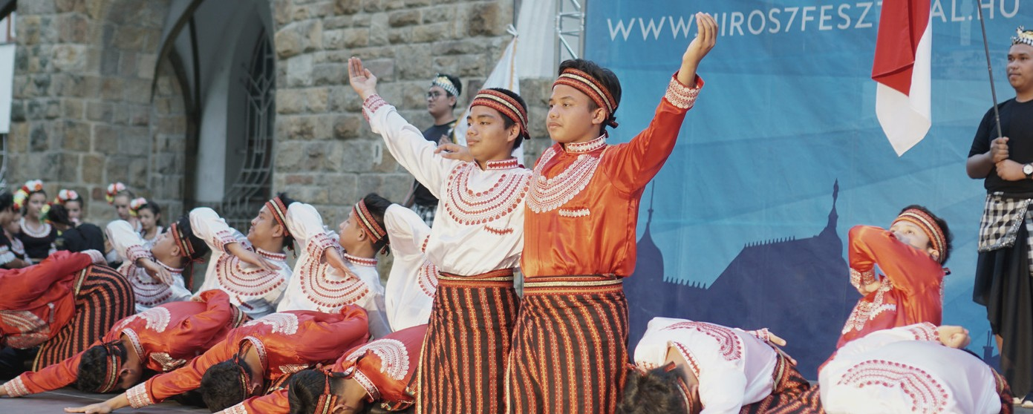

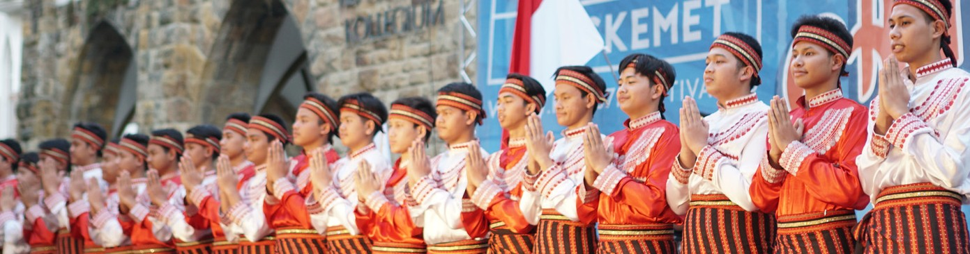

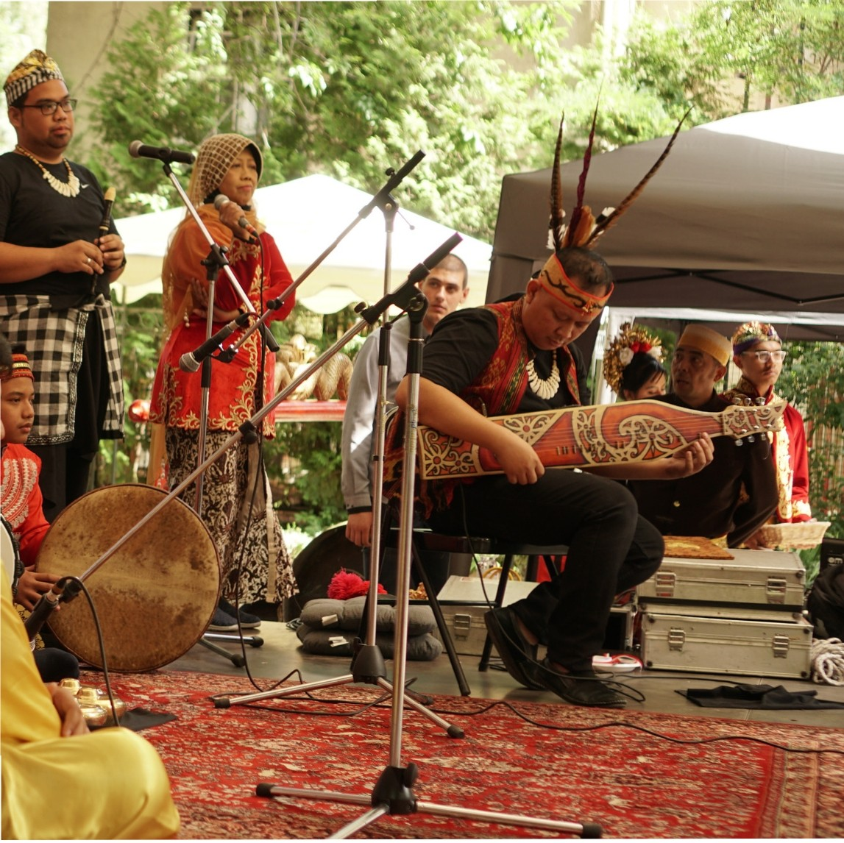

Traditional Music

INDONESIA

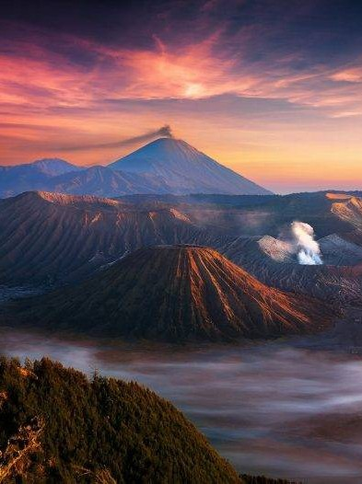W O N D E R F U L I N D O N E S I A

WONDERFUL
INDONESIA

L A N D S C A P E

C O N T T A C T .

0 1 E M A I L

k i n a n t h i b u d a y a @ g m a i l . c o m

0 2 P H O N E

A R T D I R E C T O R
D E S T R I A N E W R E Z K Y
+ 6 2 8 1 2 8 8 3 1 5 3 4 1
0 3 W E B S I T E

w w w . k i n a n t h i b u d a y a . c o m

0 4 S O C I A L M E D I A

I N S T A G R A M
@ k i n a n t h i b u d a y a

P R O J E C T D I R E C T O R

K E M B A R A Q H
+ 6 2 8 1 2 2 2 2 4 8 3 2 2

